- Write a programe to demonstrate the use of volatile keyword.
package multithreading;
class vol extends Thread {
private static volatile int counter=0;
public void run()
{
for (int i=0;i<5;i++)
{
counter++;
System.out.println(counter);
try {
Thread.sleep(500);
} catch (InterruptedException e) {
e.printStackTrace();
}
}
}
}
public class q1{
public static void main(String[] args) {
vol t1= new vol();
vol t2= new vol();
t1.start();
t2.start();
}
}

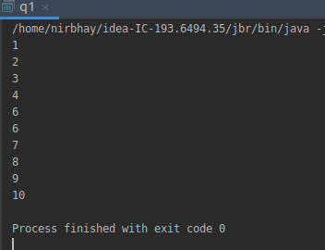

- Write a program to create a thread using Thread class and Runnable interface each.

package multithreading;
class a1 extends Thread{
public void run()
{
for (int i=1;i<=3;i++)
{
System.out.println(i);
}
}
}
class a2 implements Runnable{
public void run()
{
for (int i=4;i<=6;i++)
{
System.out.println(i);
}
}
}
public class q2 {
public static void main(String[] args) {
a1 obj1=new a1();
obj1.start();
Thread t1=new Thread(new a2());
t1.start();
}
}

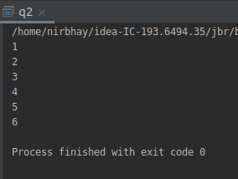

- Write a program using synchronization block and synchronization method

package multithreading;
class syn1{
public synchronized void fun1()
{
for (int i=1;i<=2;i++)
{
System.out.println("syn method " + i);
try
{
Thread.sleep(500);
}
catch (Exception e)
{
System.out.println(e);
}
}
}
public void fun2()
{
System.out.println("hello");
synchronized (this)
{
for (int i=3;i<=4;i++)
{
System.out.println("syn block " + i);
try
{
Thread.sleep(500);
}
catch (Exception e)
{
System.out.println(e);
}
}
}
}
}
class syn2 extends Thread{
syn1 obj;
syn2(syn1 o)
{
this.obj=o;
}
public void run()
{
obj.fun1();
obj.fun2();
}
}
public class q3 {
public static void main(String[] args) {
syn1 x=new syn1();
syn2 obj1=new syn2(x);
syn2 obj2=new syn2(x);
obj1.start();
obj2.start();
}
}

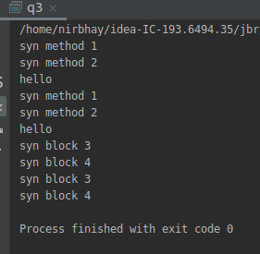

- Write a program to create a Thread pool of 2 threads where one Thread will print even numbers and other will print odd numbers.

package multithreading;
import java.util.concurrent.ExecutorService;
import java.util.concurrent.Executors;
class tp extends Thread
{
private int id;
tp(int id)
{
this.id=id;
}
public void even(int id)
{
for (int i=1;i<=10;i++)
{
if (i%2==0)
System.out.println(i);
}
}
public void odd(int id)
{
for (int i=1;i<=10;i++)
{
if (i%2!=0)
System.out.println(i);
}
}
public void run()
{
System.out.println(Thread.currentThread().getName() + " starting " + id);
if (id==1)
even(id);
else
odd(id);
try {
Thread.sleep(1000);
}
catch (Exception e)
{
System.out.println(e);
}
System.out.println(Thread.currentThread().getName() + " completed " + id);
}
}
public class q4 {
public static void main(String[] args) {
ExecutorService exec= Executors.newFixedThreadPool(1);
for (int i=1;i<=2;i++)
{
exec.submit(new tp(i));
}
exec.shutdown();
}
}
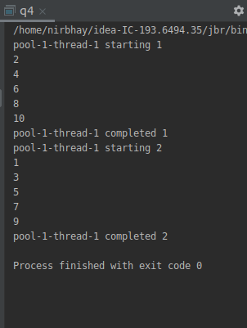

- Write a program to demonstrate wait and notify methods.

package multithreading;
public class q5 {
public void fun1()
{
synchronized (this){
System.out.println("thread 1");
try {
Thread.sleep(1000);
System.out.println("thread 1 waiting");
wait();
} catch (InterruptedException e) {
e.printStackTrace();
}
System.out.println("Resumed thread 1");
}
}
public synchronized void fun2()
{
synchronized (this)
{
System.out.println("thread 2");
try {
Thread.sleep(1000);
} catch (InterruptedException e) {
e.printStackTrace();
}
System.out.println("notifying thread 1");
notify();
}
}
public static void main(String[] args) {
q5 A=new q5();
Thread obj1=new Thread(new Runnable(){
public void run()
{
A.fun1();
}
});
Thread obj2=new Thread(new Runnable(){
public void run()
{
A.fun2();
}
});
obj1.start();
obj2.start();
}
}
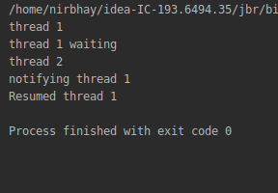

- Write a program to demonstrate sleep and join methods.

package multithreading;
public class q6 extends Thread{
public void run()
{
for(int i=1;i<=5;i++){
System.out.println(i);
try{
Thread.sleep(1000);
}
catch(Exception e){
System.out.println(e);
}
}
}
public static void main(String[] args) {
q6 t1=new q6();
q6 t2=new q6();
t1.start();
try{
t1.join();
}catch(Exception e){System.out.println(e);}
t2.start();
}
}

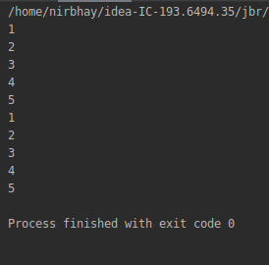

- Run a task with the help of callable and store it's result in the Future.

package multithreading;
import java.util.concurrent.*;
class call implements Callable
{
int count=0;
public Integer call() throws Exception
{
for (int i=0;i<5;i++)
{
count++;
}
return count;
}
}
public class q7 {
public static void main(String[] args) throws Exception {
ExecutorService executorService= Executors.newCachedThreadPool();
Future<Integer> future=executorService.submit(new call());
executorService.shutdown();
System.out.println(future.get());
}
}
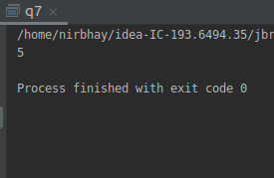

- Write a program to demonstrate the use of semaphore

package multithreading;
import java.util.concurrent.Semaphore;
class sem extends Thread{
static int count=0;
Semaphore s;
sem(Semaphore s)
{
this.s=s;
}
public void run()
{
System.out.println(Thread.currentThread().getName() + " starts");
try {
s.acquire();
} catch (InterruptedException e) {
e.printStackTrace();
}
System.out.println(Thread.currentThread().getName() + " acquires lock");
count++;
System.out.println("count= "+count);
try {
Thread.sleep(2000);
} catch (InterruptedException e) {
e.printStackTrace();
}
System.out.println(Thread.currentThread().getName() + " releases lock");
s.release();
}
}
public class q8 {
public static void main(String[] args) {
Semaphore s1=new Semaphore(1,true);
sem obj1=new sem(s1);
sem obj2=new sem(s1);
obj1.start();
obj2.start();
}
}
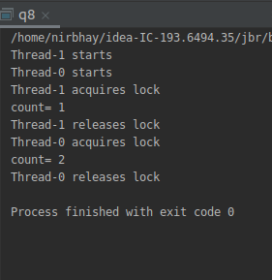

- Write a program to demonstrate the use of CountDownLatch

package multithreading;
import java.util.concurrent.CountDownLatch;
class cl extends Thread
{
private CountDownLatch latch;
private int id;
cl(int id, CountDownLatch latch)
{
this.id=id;
this.latch=latch;
}
public void run()
{
try {
Thread.sleep(2000);
}
catch (Exception e)
{
System.out.println(e);
}
System.out.println(Thread.currentThread().getName() + " starting " + id);
System.out.println(Thread.currentThread().getName() + " completed " + id);
latch.countDown();
}
}
public class q9 {
public static void main(String[] args) throws InterruptedException{
CountDownLatch latch = new CountDownLatch(2);
cl obj1=new cl(1,latch);
cl obj2=new cl(2,latch);
cl obj3=new cl(3,latch);
cl obj4=new cl(4,latch);
obj1.start();
obj2.start();
latch.await();
obj3.start();
obj4.start();

}
}
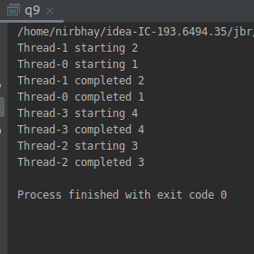

- Write a program which creates deadlock between 2 threads
package multithreading;
class d1 extends Thread
{
final Object lock1 = new Object();
final Object lock2 = new Object();
public void fun1()
{
synchronized (lock1)
{
System.out.println("Thread 1: Holding lock 1");
try {
Thread.sleep(1000);
}
catch (InterruptedException e) {
System.out.println(e);
}
System.out.println("Thread 1: Waiting for lock 2");
synchronized (lock2) {
System.out.println("Thread 1: Holding lock 1 & 2");
}
}
}
public void fun2()
{
synchronized (lock2) {
System.out.println("Thread 2: Holding lock 2");
try {
Thread.sleep(1000);
}
catch (InterruptedException e) {
System.out.println(e);
}
System.out.println("Thread 2: Waiting for lock 1");
synchronized (lock1) {
System.out.println("Thread 2: Holding lock 1 & 2");
}
}
}
}
public class q10 {
public static void main(String[] args) {
d1 obj=new d1();
Thread t1 = new Thread(new Runnable(){
@Override
public void run() {
obj.fun1();
}
});
Thread t2 = new Thread(new Runnable(){
@Override
public void run() {
obj.fun2();
}
});
t1.start();
t2.start();
}
}

